FACULTY PROFILE

PERSONAL PROFILE:
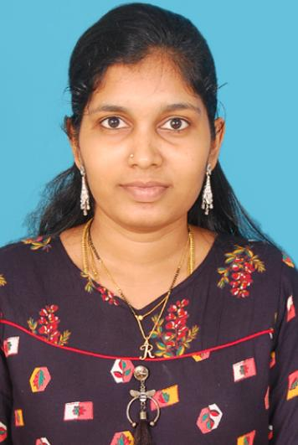
Name :. U.HEMALATHA
Father’s Name : U.Bhimarao
Date of Birth : 19-04-1995
Sex : Female
CFMS Id :
Marital Status : Married
Caste : Hindhu mala SC
Nationality : Indian
Language known :. English, Telugu,
Present Address: : 4-89/1 kontheru,Elamanchili mandal,W.G dist

Phone No :. 9866907025

ACADEMIC QUALIFICATIONS:
M.A English 2015-17 Adikavi Nannaya University RJY with 56%
Bsc Computers 2012-15 Aditya Degree college palakol With 75%
Intermediate 2010-2012 Aditya jr college, Narasapuram with 72.5%
SSC 2009-10 ZPPHS kontheru with 82.16%

TECHNICAL QUALIFICATIONS:
- DCA

Experience :
- Worked as a English lecturer in Sri Vidya Jr college, Bhimavaram for one year
- Worked as a English teacher In Sri Chaitanya Techno school, Bhimavaram for 4 months
- Now working as a Guest Guest faculty in Sri DNR GDC (W),Palakol from 09-02-2022

